CSE307 NETWORKING LAB REPORT

On

Multi-floor Office Network Setup and Configuration

Submitted by: Rishi naga sai Mukka Submitted to:

Registration No: 12305908 Mr. Simarjit Singh Malhi

Section:K23UP

Roll No: 14



GitHub Repository Link: https://github.com/rishighb/networking.git

Physical Scenario Creation:

This network represents a seven floor building of a mid-sized enterprise named XL Network Solutions, where each floor has its own set of 8 PC’s each. The first two floors follow a star topology followed by mesh topology on the successive two floors and the remaining floors are accompanied by ring topology. Each floor has its own dedicated 2960 switch which is connected to all devices on floor using fast ethernet ports. Each floor has its own 2911 router and the routers of each floor are connected in a bus topology for a seamless connection.

To connect the floors with each other, we used Gigabit Ethernet ports available on the routers and switches. Specifically, each floor's switch connects to its floor router using Gigabit Ethernet, and routers of adjacent floors are also interconnected through Gigabit Ethernet ports to ensure faster communication and better bandwidth for inter-floor data transfer.

Following are the snapshots of the physical layout of the entire network :

Fig 1. Floors 1-3

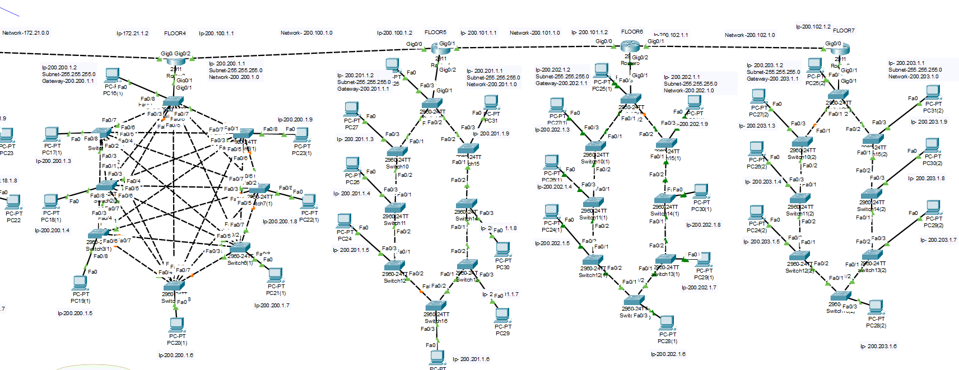

Fig 2. Floors 4-7

Fig3. Entire network Floors 1-A diagram of a network

AI-generated content may be incorrect.

Switch used - 2960

Router used – 2911

Floor 1 and Floor 2 – Star Topology

Floor 3 and Floor 4 – Mesh Topology

Floor 5, 6 and 7 - Ring Topology

IP Addressing

To ensure proper segmentation and clear identification of devices, we assigned IP addresses floor-wise.

* Floors 1, 2, and 3 use **Private IPv4 Class B** addresses.
* Floors 4, 5, 6, and 7 use **Public IPv4 Class C** addresses.

|  |  |  |
| --- | --- | --- |
| Floor No. | Gateway | Ip’s for PC’s |
| 1 | 172.16.1.1 | 172.16.1.2 – 1.9 |
| 2 | 172.17.1.1 | 172.17.1.2 – 1.9 |
| 3 | 172.18.1.1 | 172.18.1.2 – 1.9 |
| 4 | 200.200.1.1 | 200.200.1.2 – 1.9 |
| 5 | 200.201.1.1 | 200.201.1.2 – 1.9 |
| 6 | 200.202.1.1 | 200.202.1.2 – 1.9 |
| 7 | 200.203.1.1 | 200.203.1.2 – 1.9 |

Table 1. Floor-wise Gateway and IP configuration

|  |  |
| --- | --- |
| Floor 1 | Floor 2 |
| Floor 3 | Floor 4 |
| Floor 5 | Floor 6 |
| Floor 7 |  |

Table 2. Snaps of IP configuration window from a pc of each floor

Router IP Configuration:







Fig 4. Ex.IP addressing of Floor 4’s router in CLI

Routing

In our project, we used RIP (Routing Information Protocol) for dynamic routing between the floor routers. RIP was configured on each floor’s router, allowing the routers to automatically exchange routes and learn about networks on other floors.

This makes sure that devices from one floor can communicate with devices on any other floor without needing manual static routes for each connection.

|  |
| --- |
| Floor 1 |
| Floor 2 |
| Floor 3 |
| Floor 4 |
| Floor 5 |
| Floor 6 |
| Floor 7 |

Table 3. Snaps of dynamic routing between routers using rip command on CLI

Communication between PC’s

To check communication between pc’s we used the ping command in the command prompt and to see the paths we used tracert command also to see flow of packets.

|  |
| --- |
| Floor 1 to 1 |
| Floor 1 to 2 |
| Floor 1 to 3 |
| Floor 1 to 4 |
| Floor 1 to 5 |
| Floor 1 to 6 |
| Floor 1 to 7 |

Table 4. Snaps of inter-communication between pc’s of all floors

Using the ping command.

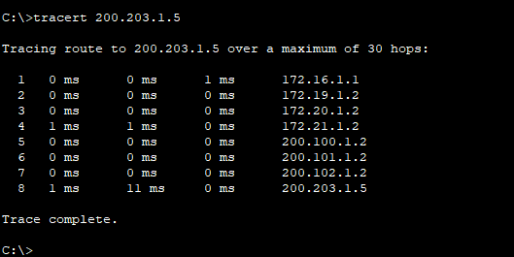

Fig 5. Use of Tracert command on floor 1’s pc to floor 7’s pc to see flow of data to trace the route.